# Evolution through Programming

Lecturer: Prof. Yitzhak Pilpel  
TA: Omer Kerner – [omer.kerner@weizmann.ac.il](mailto:omer.kerner@weizmann.ac.il)

## Assignment 1

**By Sarit Moses (211772900) and Itamar Nini (207047150)**

Simulations:

We simulated 100 experiment replications for each of the models (300 simulations total for 3 models). Each simulation assigned the bacteria some probability to replicate, some probability to gain a mutation and some probability to die. We set the mutation probability to 0.1 (to see the effect in a smaller number of simulation replications), the initial probability to replicate was set to 1 (healthy replicating bacteria) and the probability to die was set to 0.01 (bacteria may die before replicating at a very low rate). As a bacterium gains a mutation, its probabilities to replicate and die were slightly modified (randomly) to simulate cost effects of the mutations in comparison to the ground state. When added stress, all non-mutated bacteria were assigned with a much higher death probability to show their response to stress, and mutated bacteria were assigned with a random probability to die that was lower than the non-mutated bacteria, showing that different mutations may have different size of advantage when encountering the stress. In stress conditions, all mutations had a lower probability to die than the original ground state, because the experiment only witnesses colonies that managed to survive so we assumed all mutations to be beneficial. The Lamarckian model supports the assumption that all mutations are beneficial. Each experiment ran for 10 generations before applying the stress and then continued for one additional generation after stress application.

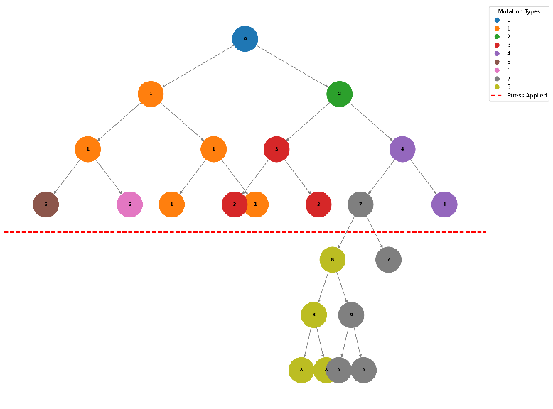The figure below shows the propagation of a single experiment for a lower number of generations, as a visualization of the creation of the population. The stress was applied after 3 generations, and the bacteria that survived continued to propagate for 3 more generations. The probability of mutation was set higher so the effect could be seen.

Calculations:

This following figure shows the distribution of the number of surviving colonies, in each of the proposed models. As can be seen, while in the Lamarckian model run (orange histogram) we get a very small mean and relatively small variance, in the Darwinian model run (blue distribution) we get higher survival numbers with a larger variation. A combination of the two models (green histogram) yields a distribution that is like the Darwinian one, but with a higher mean since there are added mutations at the last (and largest) generation.

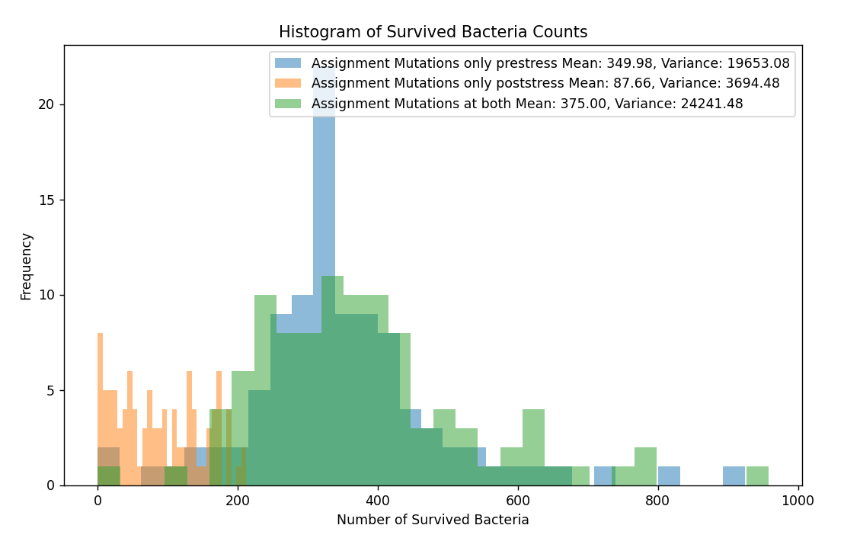

The non-Poissonian distribution for the Lamarckian model here is because we randomly assigned a survival benefit to each of the possible mutations, so our model checks more than one possible mutation and not all of them allow survival (which creates more variance). A simpler model would generate a more Poisson-like distribution. The figures below show two different distributions acquired from running the simpler model, with 10 generations and probability 0.1 for occurrence of mutation. In this scenario the Lamarckian model indeed results in a Poisson distribution.

Both models are attached.

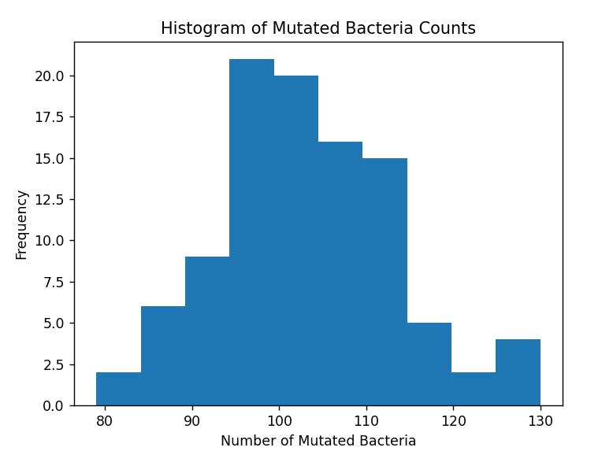תמונה שמכילה טקסט, צילום מסך, תרשים, גופן

תוכן שנוצר על-ידי בינה מלאכותית עשוי להיות שגוי.

**Left: Lamarckian model:** mean=103.09, variance=101.18

**Right: Darwinian model:** mean=453.38, variance=3099.48

Explanation:

The Luria–Delbrück experiment set out to test if mutations happen randomly and are brought to attention in response to stress (Darwinian model) or happen only in response to a stress (Lamarckian model). Their experiment consisted of many repeats of the same experiment, in which bacteria were grown in rich media to form a culture and then plated on an agar plate containing antibiotics. In each of these repeated experiments, the number of colonies that were able to grow on the antibiotics (resistant colonies due to mutations) was documented.

Under the Lamarckian model, mutations were expected to occur only on the last generation of the culture (the plated bacteria) and therefore when repeated many times should behave like a Poisson distribution, with a small mean that is equal to the variance. Alternatively, the Darwinian model allows mutations to happen also earlier in the process, resulting in sometimes much larger fractions of the population to be resistant to the antibiotics – therefore the distribution is expected to be broader, with a long tail. The result of the actual experiment of Luria–Delbrück was consistent with the expectancy for a broad distribution with large variance, therefore providing evidence that mutations occur via Darwinian evolution.